Revision History

|  |  |  |  |
| --- | --- | --- | --- |
| Date | Version | Description | Author |
| 09/03/2012 | V1.01 | Modified formatting to fit quality standards | Mark Robinson |
| 09/03/2012 | V1.02 | Modified navigation | Mark Robinson |
| 09/03/2012 | V1.03 | Modified use case diagram to improve legibility | Mark Robinson |
| 19/03/2012 | V1.04 | Title page added, revision history finalised | Mark Robinson |
|  |  |  |  |
|  |  |  |  |
|  |  |  |  |
|  |  |  |  |
|  |  |  |  |
|  |  |  |  |
|  |  |  |  |
|  |  |  |  |
|  |  |  |  |
|  |  |  |  |
|  |  |  |  |
|  |  |  |  |
|  |  |  |  |
|  |  |  |  |
|  |  |  |  |
|  |  |  |  |
|  |  |  |  |
|  |  |  |  |
|  |  |  |  |
|  |  |  |  |
|  |  |  |  |
|  |  |  |  |
|  |  |  |  |
|  |  |  |  |
|  |  |  |  |
|  |  |  |  |
|  |  |  |  |
|  |  |  |  |
|  |  |  |  |
|  |  |  |  |
|  |  |  |  |
|  |  |  |  |
|  |  |  |  |



K.A.E Experience Centre Management System

Phase 2 Documentation

V1.04

19/03/2012

Theme

# Colour scheme

* The colour scheme will be green and white.

e.g.

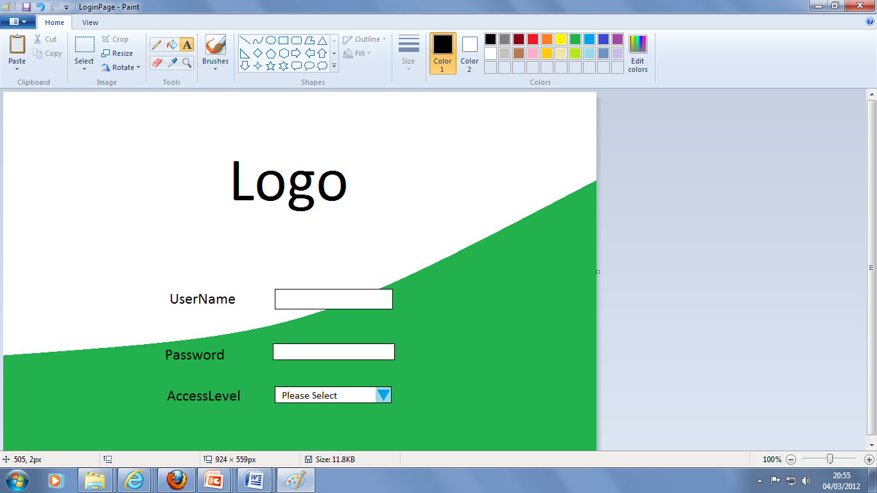

# Overall layout

* The controls of the login form will be centred to the frame
* All other pages shall be left aligned for all other pages.

# Font

* The font will be black Ariel

# Controls

* Combo Boxes
* List boxes
* Text fields
* Menu buttons
* Display Tables

# What the system does

* The System will create a log in page for the customer which will require user input to allow further access into the system.
* After log in, the user will be presented with a menu to complete a transaction or to search data or add a new record.
* The complete a transaction creates a form to fill in which will record transaction details
* The search data option will allow the user to search for a particular data field for records which will be presented in a tabulated format.
* The add a new record option will add a record of customer, supplier, staff or stock.



## Additional Functionality

* All pages lower than the Menu page in the hierarchy should have an option to return to menu.
* The menu page should have the option to ‘log-out’ to the log in page.

Use Case Diagram



|  |  |
| --- | --- |
| Task | User Access |
| Log into the System | All users |
| Complete Transaction | Employee and Manager |
| Enter Customer Information | All users |
| Enter Product information | All users |
| Enter Supplier Information | All users |
| Enter Staff Information | Admin and Manager |
| Search and View Information | All users |

* Admin should have access to majority of database but for maintenance and testing purposes only.
* Employee should not be able to view other staff information.

Top level DFD

